IoT Design Methodology

# Definition

* It refers to the structured approach used to plan, develop, and implement an Internet of Things (IoT) system.
* It involves a series of steps that guide the entire process, from understanding the business objectives and technical requirements to the final application development and deployment.

# Step 1: Purpose & Requirement Specification

* **Purpose**: A DDS based dam door controller ensures efficient, real-time monitoring and automatedcontrol of the dam's door mechanism based on critical environmental data.
* **Behavior**: System should provide manual and automatic modes and have ability to switch remotely.
* **Data Analysis Requirement**: The system should perform local system analysis.
* **Application Deployment Requirement**: The application should be deployed locally but access remotely.
* **Security Requirement**: The system should have basic user authentication capability.

# Step 2: Process Model Specification

* **The dam door operates in two modes—Auto and Manual:**

1. Auto Mode**:** The system automatically adjusts the door position based on sensor data, responding to changes in water level, pressure, and flow rate.
2. Manual Mode**:** Allows authorized personnel to override the automatic system and control the door directly.

* **Door Status and Control:**

1. The system monitors whether the door is open or closed and adjusts the percentage of door opening based on environmental conditions.
2. Commands are sent to open or close the door to a specific degree (e.g., 25%, 50%) to optimize flow control.
3. Sensors continuously feed data on water level, pressure, and flow rate, allowing the system to make real-time adjustments as conditions change.

* **Safety Overrides:**

1. In emergencies, the system can fully open or close the door regardless of other settings, ensuring dam and environmental safety.
2. **This process ensures responsive and flexible control over the dam door while prioritizing safety and operational efficiency.

*Process specification for dam door management IoT system*

# Step 3: Domain Model Specification

* The domain model defines the main entities, their attributes, and the relationships between them. This provides an abstract representation of the components involved in the IoT domain.
* **Key Entities and Their Attributes**

1. **Physical Entity (Dam and Environment)**

* **Attributes**: Water level, pressure, flow rate, emergency status, door position.
* **Relationships**: These physical attributes are monitored by sensors and serve as inputs for decision-making processes regarding the dam door’s operation.

1. **Virtual Entity (Dam Control System)**

* **Attributes**: Control mode (Auto/Manual), door status, actuation threshold values, emergency override status.
* **Relationships**: The virtual entity processes data from physical entities, performs analytics, and commands actuation subscribers based on predefined conditions.

1. **Device (Sensors and Actuators)**

* **Attributes**: Ultrasonic sensors, Pressure Transducers, Laser sensors, EMW Flow Meters sensor reads data with timestamp.
* **Relationships**: Sensors gather data on the dam’s physical conditions, sending it to the central subscriber for aggregation and analysis.

1. **Resources (Data and Analytics Resources)**

* **Attributes**: Data type (real-time sensor data, historical data), storage location, data processing algorithms.
* **Relationships**: Resources support data analysis, storage, and retrieval, enabling the system to make informed decisions based on real-time conditions.

1. **Services (Control and Monitoring Services)**

* **Attributes**: Service ID, service type (monitoring, control), frequency of operation, priority level.
* **Relationships**: Services allow interaction between users and the system, such as monitoring real-time dam status or manually controlling the door.



*Domain specification for dam door management IoT system*

# Step 4: Information Model Specification

* It defines the data structure and the specific types of data that flow within the DDS-based dam control system. It specifies the data types, formats, and relationships between data elements.
* **Key Information Elements and Their Attributes**
  + **Water Level Data**: Records water level in meters with a timestamp. Used to monitor safe limits.
  + **Water Pressure Data**: Measures water pressure in pascals at specified depths. Assesses stress on the dam.
  + **Inflow Speed Data**: Measures inflow speed in m/s, helping control safe inflow rates.
  + **Door Status**: Indicates door position (percentage open) and current status (e.g., open, closed).
  + **Control Mode**: Specifies if the system is in "Auto" or "Manual" mode, affecting control responses.
  + **Emergency Status**: Boolean for emergency events (e.g., overflow), triggering immediate system



*Information specification for dam door management IoT system*

# Step 5: Service Specification

* It defines the services that are provided by the DDS-based dam control system, detailing the functionality, access points, and interactions between various system components (publishers, subscribers, and analytics).
* **Key Service Elements**
  + **Data Collection Service**: Gathers real-time sensor data (e.g., water level, pressure, inflow speed) and sends it to the central system for processing.
  + **Control Service**: Sends commands to actuators to adjust the dam door based on processed data or manual inputs.
  + **Data Representation Service**: Allows operators to see the data, and visualize it in table and chart format.



*Data Collection Service specification for dam door management IoT system*



* Control Service specification for dam door management IoT system*

*Data Representation Service specification for dam door management IoT system*

# Step 6: IoT level Specification

* It outlines the hierarchical structure of the IoT system, specifying the layers and their roles within the architecture. Each layer interacts with different IoT components, from physical devices to cloud-based services, and ensures that the system functions cohesively
* This dam door management system work on **IoT level 2**:

**IoT LEVEL - 2**

*IoT specification for dam door management IoT system*

# Step 7: Functional View Specification

* In the Functional View Specification, we define the functionalities of the IoT system grouped into key functional groups. Each functional group represents a set of related functions that together fulfill specific system requirements.
* **Functional Groups and Their Roles:**
  + **Device Functional Group**: Collects data (e.g., water level, pressure) and controls the dam door.
  + **Communication Functional Group**: Ensures secure data transfer between sensors, processors, and actuators.
  + **Service Functional Group**: Processes data, controls door operations, and manages emergency responses.
  + **Management Functional Group**: Enables monitoring, configuration, and system maintenance.
  + **Security Functional Group**: Protects data and access, ensuring secure operation.
  + **Application Functional Group**: Provides interfaces for operators to monitor and control the system.

1. ***IoT devices*** *maps to the Devices FG(sensors, actuators, computing devices) and management FG.*
2. ***Resources*** *maps to Devices FG(on-device resource) and Communication FG(comm. API’s protocol).*
3. ***Controller******service*** *maps to Service FG(native service). Web Service map to Service FG(web service).*
4. ***Web******Service*** *maps to Service FG(web service).*
5. ***Database*** *maps to the management FG(db management) and Security FG(db security)*
6. ***Application*** *maps to the Application FG(web app, database servers,) Management FG(app management) and Security FG(app security).*

# Step 8: Operation View Specification

* It defines various options for deploying and running the IoT-based dam control system. This includes choices related to hosting, storage, device management, and application deployment.
* **Key Operation follow as below:**
  + **Devices**: Computing Device (Raspberry Pi), Relay Switch(actuator), Sensor (LIDAR, Ultrasonic, Hydrostatic and Flow meter).
  + **Communication API:** REST APIs
  + **Communication Protocol:** Link layer - 802.11, Network layer – Ipv4/Ipv6
  + **Services:**
    - **Data Collection Service:** Hosted on device, implemented in python run as native service.
    - **Control Service:** Restful web service, hosted on device and implemented in python.
    - **Data Representation Service:** Restful web service, hosted on device and implemented in python
* **Application:**
  + **Web Application:** Taipy
  + **Database:** Firebase NoSQL database
* **Security:**
  + **Authentication:** Web App, Database
  + **Authorization:** Web App, Database



*Operational View specification for dam door management IoT system*

# Step 9: Device and Component Integration

* This step involves integrating all physical and digital components to ensure smooth communication and functionality within the IoT-based dam control system. In this project devices used are Computing Device (Raspberry Pi), Relay Switch(actuator), Sensor (LIDAR, Ultrasonic, Hydrostatic and Flow meter).



*Device and Component Integration for dam door management IoT system*

# Step 10: Application Development

* 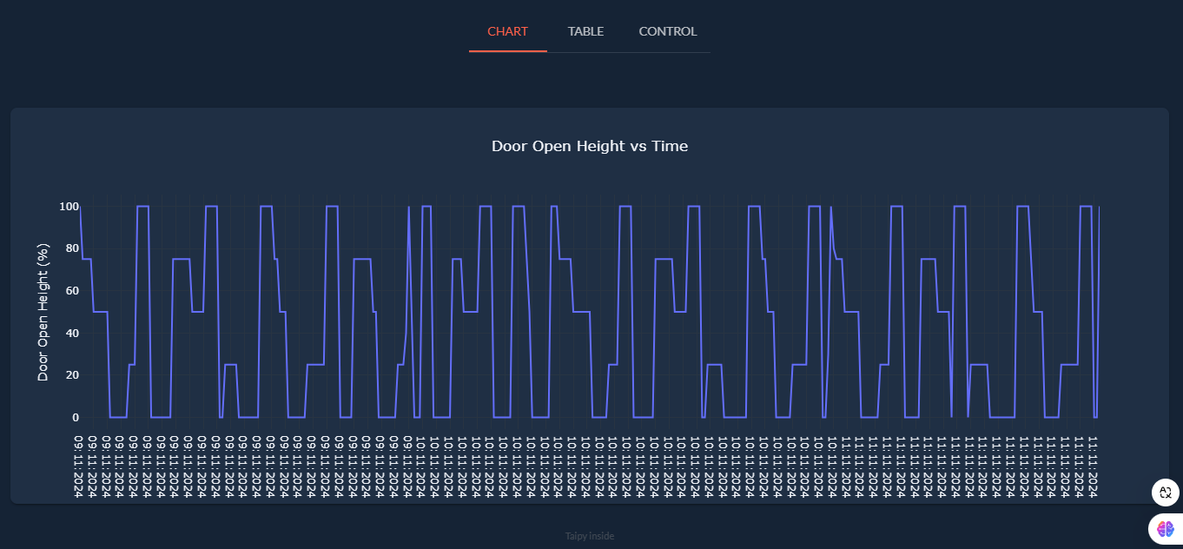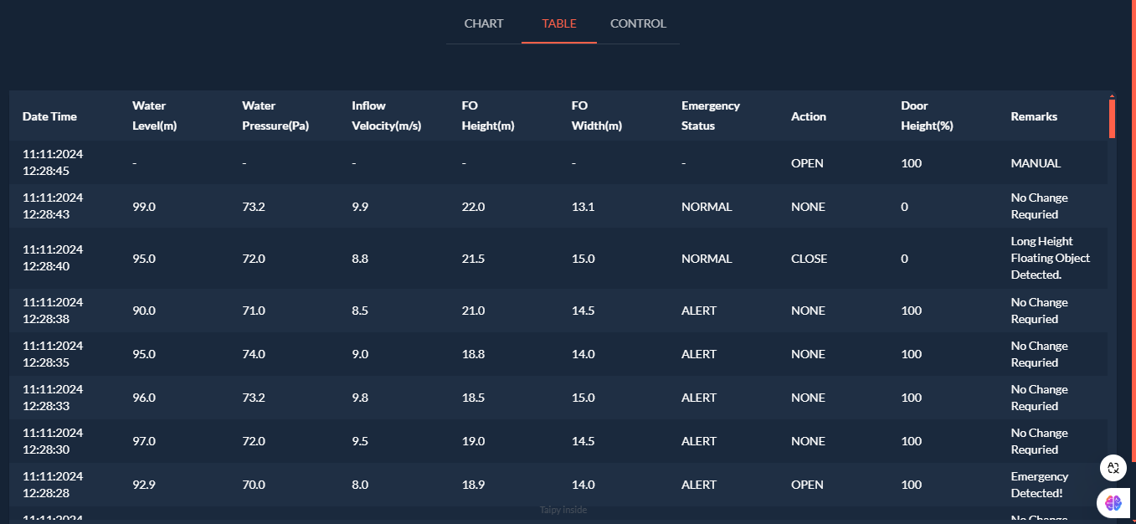This step describes the methodology to develop the IoT application especially the front end of the application. It focuses on building and deploying the software applications needed for the dam control system’s operation, monitoring, and management. This includes developing interfaces, control logic, and reporting features that enable user interaction and automated control.